USERMANUAL

Table of Contents

Registration 2

Admin Registration 2

Student Registration 3

Login 5

Student Dashboard 7

Service Type 7

Student Compliant/Query Form 8

Search List Option 11

Registration

1. Graphical user interface, application

   Description automatically generatedLaunch the application and navigate to the registration screen from the main menu. It should look like the image below:

Admin Registration

1. Complete the registration form. Fill out the respected fields with the relevant information, then click the Register Admin button.

1. Graphical user interface, application

   Description automatically generatedIf all steps are followed properly the following screen will indicate a successful registration, simply select ok to continue.

Student Registration

1. Complete the registration form. Fill out the respected fields with the relevant information, then click the Register Student button.

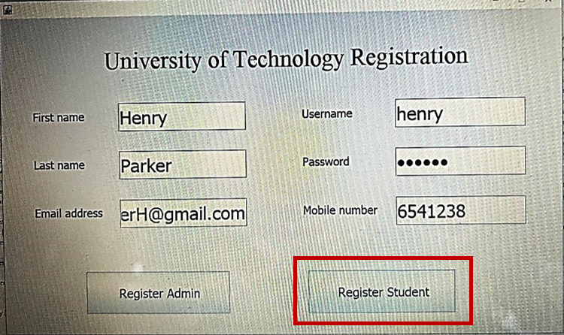

1. If all steps are followed properly the following prompt will indicate a successful registration, simply select ok to continue.

Login

1. Navigate to Login Page

1. Enter Your Login Information by filling out the username and password field then clicking the type of login that applies.

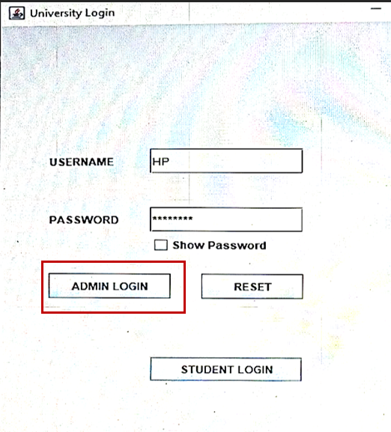

1. If all steps are followed properly the following or a similar prompt will indicate a successful login, simply select ok to continue.

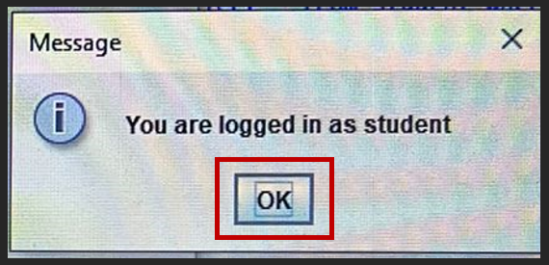

# Student Dashboard

1. Login as a student on order to access the student dashboard (see the login dashboard for more information).

## Service Type

1. Select service type to lodge a complaint of query.

1. Select either query or complaint.

## Student Compliant/Query Form

1. Select complaint to see the complaint form.

1. Enter id number then press the enter key and the form should fill up to contact number. Select issue Type and whether complaint or query type.

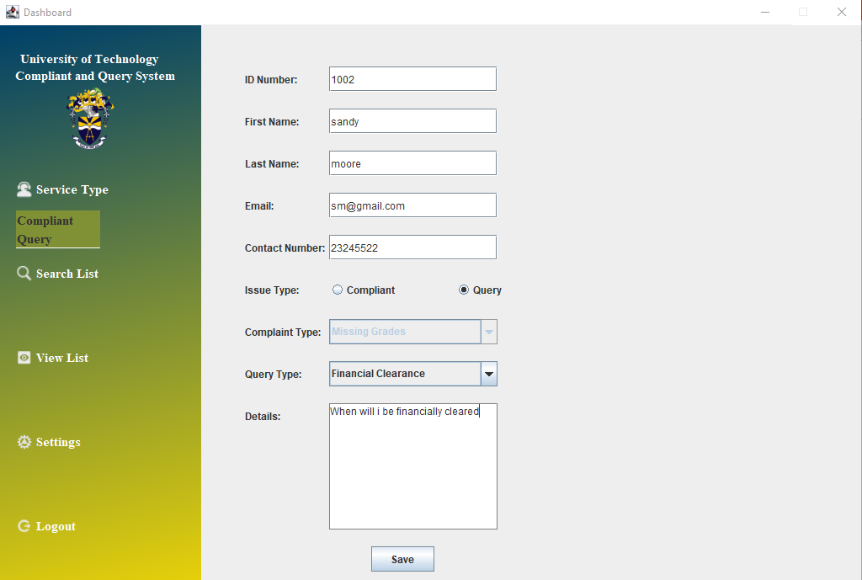

1. If successful the following prompt will be be displayed simply select ok to move on.

## Search List Option

1. Selecting the search should give the following display.

1. Fill out the complaint/query and id number and select the search button

